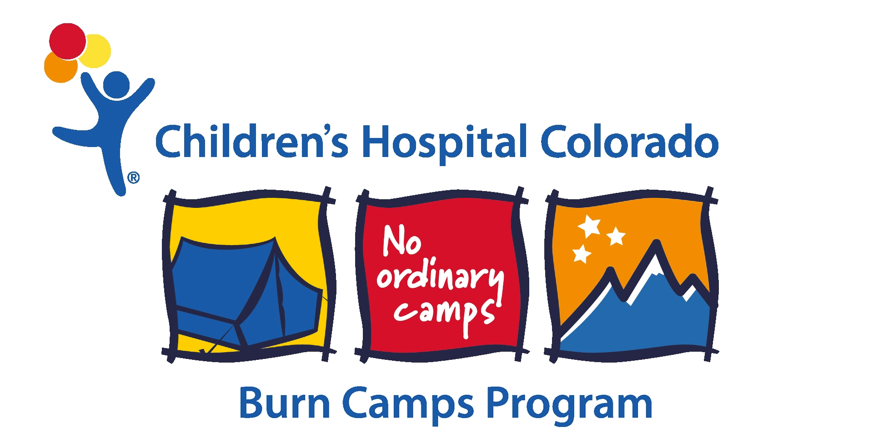

November 17, 2014

Dear Camper,

Thank you for completing your registration for The Children’s Hospital Colorado Winter Camp Program. We are excited for you to join us in challenging yourself and learning new skills in beautiful Steamboat Springs.

If you need to reach us during the week, here are the lodging details.

Host Lodge: The Steamboat Grand Resort
Steamboat Springs, Colorado
Telephone: 970-871-5500

EMERGENCY TELEPHONE NUMBERS:

Trudy Boulter, Director
Prior to Winter Camp: (720) 777-8295
Trudy.boulter@childrenscolorado.org

During camp:
(303)929-3609

TRANSPORTATION:

We will send transportation information in an additional letter.

All campers will meet at Denver International Airport. Firefighters be waiting to meet you at the airport, help with luggage, and transport you to the Steamboat Grand Hotel. On your return flight, the procedure will work the same way. You will be transported to the airport and a staff person will assist you with luggage check-in and then see you safely on your way. The airport paging number is (303) 342-2000.

